STAT 8120 – Module 8 Homework

Due 4/12/2020

Connor Armstrong

***8.4*** *Problem 6.30 describes a process improvement study in the manufacturing process of an integrated circuit. Suppose that only eight runs could be made in this process. Set up an appropriate 25−2 design and find the alias structure. Use the appropriate observations from Problem 6.28 as the observations in this design and estimate the factor effects. What conclusions can you draw?*

**8.4 Conditions**

|  |
| --- |
| *8.411 Data is obtained from problem 6.30. Compare results with full model analysis of 6.30 data.* |

***Table 8.4.1 Unreplicated 25 Design from Problem 6.30***

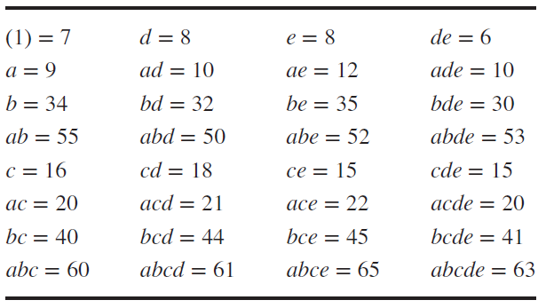

The first step for manually generating a one-quarter fractional factorial design is to write the main effects design matrix for k-2 factors. This design is a full main effect basic design for 5-2=3 factors A, B, and C having 8 runs.

Table 8.4.2 Creating a 25-2III Design from a 23 Design Matrix

|  |  |  |  |  |
| --- | --- | --- | --- | --- |
| **Basic Design** | | | **New Factors** | |
| **A** | **B** | **C** | **AB=D** | **AC=E** |
| - | - | - | + | + |
| + | - | - | - | - |
| - | + | - | - | + |
| + | + | - | + | - |
| - | - | + | + | - |
| + | - | + | - | + |
| - | + | + | - | - |
| + | + | + | + | + |

The second step is to evaluate the generating relations and the defining relation for the fractional design. The generating relations ie design generators for the selected design are I = ABD and I = ACE and the defining relation becomes I = ABD = ACE = ABD*ACE = BCDE.

The third step is to evaluate the “new factors” as shown in table 8.4.2.

The fourth step is to declare the complete defining relation: I = ABD = ACE = ABD*ACE = BCDE.

The fifth step is to evaluate the aliasing structure:

A = A*I = A*ABD = BD; A = A*ACE = CE; A = A*BCDE = ABCDE

A = BD = CE = ABCDE

B = AD = ABCE = CDE

C = ABCD = AE = BDE

D = AB = ACDE = BCE

E = ABDE = AC = BCD

BC = ACD = ABE = DE

BE = ADE = ABC = CD

The appropriate observations are selected and displayed in the table below along with the design matrix:

Table 8.4.3 One-Quarter Design with Selected Observations

|  |  |  |  |  |  |  |
| --- | --- | --- | --- | --- | --- | --- |
| **Basic Design** | | | **New Factors** | | **Selected Observations** | |
| **A** | **B** | **C** | **AB=D** | **AC=E** | **Combination** | **Response** |
| - | - | - | + | + | DE | 6 |
| + | - | - | - | - | A | 9 |
| - | + | - | - | + | BE | 35 |
| + | + | - | + | - | ABD | 50 |
| - | - | + | + | - | CD | 18 |
| + | - | + | - | + | ACE | 22 |
| - | + | + | - | - | BC | 40 |
| + | + | + | + | + | ABCDE | 63 |

Upon evaluation of the factorial design, the p-values for each factor cannot be determined having 0 degrees of freedom for error. Nonetheless, the estimated factor effects and half-normal probability plot can be analyzed.

**Analysis of Variance**

|  |  |  |  |  |  |  |  |
| --- | --- | --- | --- | --- | --- | --- | --- |
| **Source** | **DF** | **Seq SS** | **Contribution** | **Adj SS** | **Adj MS** | **F-Value** | **P-Value** |
| Model | 7 | 2837.87 | 100.00% | 2837.87 | 405.41 | * | * |
| Linear | 5 | 2825.62 | 99.57% | 2825.62 | 565.12 | * | * |
| A | 1 | 253.13 | 8.92% | 253.12 | 253.12 | * | * |
| B | 1 | 2211.12 | 77.91% | 2211.12 | 2211.12 | * | * |
| C | 1 | 231.13 | 8.14% | 231.13 | 231.13 | * | * |
| D | 1 | 120.12 | 4.23% | 120.12 | 120.12 | * | * |
| E | 1 | 10.12 | 0.36% | 10.12 | 10.12 | * | * |
| 2-Way Interactions | 2 | 12.25 | 0.43% | 12.25 | 6.13 | * | * |
| B*C | 1 | 6.13 | 0.22% | 6.13 | 6.13 | * | * |
| B*E | 1 | 6.13 | 0.22% | 6.13 | 6.13 | * | * |
| Error | 0 | * | * | * | * |  |  |
| Total | 7 | 2837.87 | 100.00% |  |  |  |  |

The table of coefficients below lists the factor effects by term.

**Coded Coefficients**

|  |  |  |  |  |  |  |  |
| --- | --- | --- | --- | --- | --- | --- | --- |
| **Term** | **Effect** | **Coef** | **SE Coef** | **95% CI** | **T-Value** | **P-Value** | **VIF** |
| Constant |  | 30.38 | * | (*, *) | * | * |  |
| A | 11.250 | 5.625 | * | (*, *) | * | * | 1.00 |
| B | 33.25 | 16.62 | * | (*, *) | * | * | 1.00 |
| C | 10.750 | 5.375 | * | (*, *) | * | * | 1.00 |
| D | 7.750 | 3.875 | * | (*, *) | * | * | 1.00 |
| E | 2.250 | 1.125 | * | (*, *) | * | * | 1.00 |
| B*C | -1.7500 | -0.8750 | * | (*, *) | * | * | 1.00 |
| B*E | 1.7500 | 0.8750 | * | (*, *) | * | * | 1.00 |

The half-normal probability plot indicates that the estimated effect for factor B of 33.25 is significant, while the other effects do not meet the threshold for significance.

